Sapphire Education Safeguarding Procedures Manual
1. How to Use This Manual
This Safeguarding Procedures Manual should be used alongside the Sapphire Education Safeguarding Policy. The Safeguarding Policy outlines Sapphire’s safeguarding principles, roles and responsibilities.
This Manual sets out the practical steps staff must follow when responding to safeguarding concerns. All staff must be familiar with both documents.

2. Safeguarding Commitment
Safeguarding is the responsibility of all staff.
If you have any concern about a student’s safety or wellbeing, you must act immediately. Do not delay reporting or attempt to manage the situation independently.

3. Reporting a Concern
If you notice or receive a concern:
You must:
- report it immediately to a member of the Senior Team or the on-site DSL
- record the concern factually as soon as possible
- follow any instructions given by the DSL or Senior Team

Do not:
- delay reporting
- attempt to investigate
- discuss the concern with other staff unless directed
If a student is at immediate risk of harm:
Contact the Senior Team or DSL immediately
Emergency services will be contacted where required
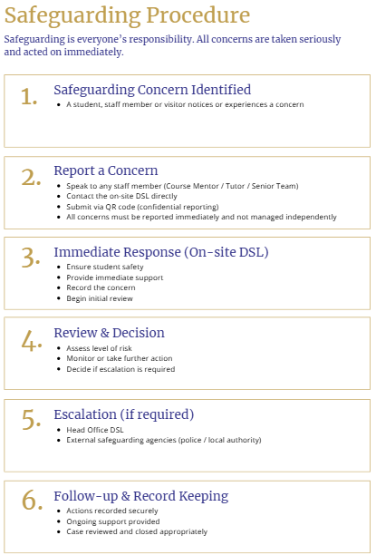

4. Responding to a Disclosure
If a student shares something with you:
You should:
- stay calm and listen carefully
- take the student seriously
- reassure them that they have done the right thing
- explain that you may need to share the information
You must not:
- promise confidentiality
- ask leading questions
- investigate or press for more detail
After the disclosure:
- record what was said, using the student’s words where possible
- report immediately to the DSL or Senior Team

5. Escalation Pathway
All concerns follow this pathway:
- Course Mentor / Academic Tutor
First point of contact for concerns or disclosures
- Senior Team / Student Welfare Lead (On-site DSL)
Reviews the concern and determines next steps
- Head Office DSL
Oversees safeguarding across all sites and liaises with external agencies
Staff must not bypass this process unless there is immediate risk

6. Recognising Safeguarding Concerns
You do not need to be certain that a concern is safeguarding-related.
If something feels wrong, report it.
Possible indicators include:
- sudden changes in behaviour
- withdrawal or distress
- unexplained injuries
- signs of bullying or exclusion
All concerns, however small, must be reported

7. Recording and Logging
All concerns must be recorded accurately and promptly.
- Record facts only, avoid opinion
- Use clear, concise language
- Submit records to the Senior Team or DSL
Where appropriate, concerns are logged in the Student Support & Monitoring Tracker. Refer to the “How to Use” tab.
Access to safeguarding records is restricted to authorised staff.

8. QR Code Reporting System
Students may raise concerns through:
- speaking to staff
- the QR code reporting system
QR submissions are:
- private
- reviewed by the DSL or Senior Team
- logged where appropriate
Staff should not attempt to access or manage QR submissions directly.

9. Staff Conduct and Boundaries
Staff must:
- maintain professional boundaries at all times
- use appropriate communication channels
- avoid over-familiarity with students
Staff must not:
- share personal contact details
- communicate with students outside approved channels

10. Residential and Programme Supervision
Students are supervised at all times through:
- Course Mentors
- Senior Team presence
- structured daily routines
Staff must:
- follow supervision procedures
- report any concerns immediately
- ensure students are accounted for during activities and transitions

11. Off-Site Activities and Excursions
During excursions:
- follow the agreed plan and risk assessment
- carry out dynamic risk assessments
- ensure students understand safety expectations
If an issue arises:
- prioritise student safety
- inform the Senior Team immediately

12. Low-Level Concerns and Whistleblowing
All concerns about staff behaviour must be reported.
This includes:
- inappropriate conduct
- boundary concerns
- behaviour that may pose a risk to students
Low-level concerns are:
- recorded
- reviewed
- monitored for patterns

13. Key Principle
You are not expected to manage safeguarding concerns alone.
- act quickly
- report clearly
- follow the process
Support is always available from the Senior Team and DSL.

